Tutorial: Data streaming between remote services using Inferno

Jon Blower (jdb@mail.nerc-essc.ac.uk)

8th September 2004

Aims of this tutorial
- Basic familiarity with the Inferno operating system
- Creation of a simple Inferno Grid Service (TODO: is IGS a suitable name? Conflict with Inferno Grid?)
- Chaining IGS instances so that data is streamed between them
- Wrapping an IGS in a Web Service and creating a workflow in Triana or another WS-based WF engine (e.g. Taverna)

Requirements
It is perfectly possible to work through this tutorial with a single computer (Windows NT/2000/XP, Linux, Solaris, MacOSX or FreeBSD). However, it is more satisfying to use two networked computers to show yourself just how easy it is to connect them and exchange data, especially if the computers are running different operating systems.
As we shall see, many Inferno commands have direct equivalents in Unix, so familiarity with Unix or Linux is useful but by no means essential. In the later stages of the tutorial we shall be doing some Java programming (to link our Inferno system with a Java-based Web Services framework) so familiarity with Java, Apache Axis and Web Services will be useful.
A three-button mouse is highly desirable for working within Inferno’s graphical environment.

Why Inferno?
With so many other distributed computing technologies out there, why are we introducing another one, which is probably less well-known than others? There are several reasons:
- Inferno is designed from the ground up for cross-platform distributed computing.
- It is a very mature technology, originating around 20 years ago in Lucent’s Bell Labs. It has been used in industrial-quality products for many years and is known to be robust.
- It is free and Open Source for non-commercial applications (see http://www.vitanuova.com/inferno/licence.html).
- It is an operating system, but is typically run as an emulated application in another host OS. In this mode it takes up less than 1MB of RAM so it is extremely lightweight (considering its background in embedded systems, this is not surprising)
- In all these platforms, Inferno provides an identical environment for its applications (i.e. true platform independence). There are no exceptions to this.
- Unix and Linux users will already be familiar with many of Inferno’s commands.

Installing Inferno
Installing Inferno is very easy:
- Download the latest version from Vita Nuova’s website at http://www.vitanuova.com/inferno/downloads.html. (At the time of writing, the latest version is the Fourth Edition, 20040905.) Unless you have a narrowband Internet connection, the easiest thing to do is to download the CD image.
- You may wish to install Inferno as a dedicated user (on Unix and Linux I normally create a user and group called inferno to own the installation), but this is optional.
- Instructions for installing are on the download page but, in a nutshell, you need to: (i) Unzip the CD image; (ii) burn to a CD; (iii) insert the CD and run the relevant installation program in the <cdroot>/install directory.
- The installation should proceed with no warnings or errors. I have heard reports of some CD burners not correctly burning the CD image, so if you get error messages, try burning the CD on a different machine (I use x-cdroast on Red Hat Linux 9 with no problems).
- Create a new user (e.g. Jon) by copying the <inferno root>/usr/inferno directory to <inferno root>/usr/Jon and giving Jon ownership of this directory and all its contents. Do this for as many users as you like.
- Set the environment variable EMU to the string “-r<inferno root>”. (e.g. setenv EMU “-r/usr/inferno” in the C shell).
- Add the directory containing the correct executables to your PATH. For example, on Linux, the executables are in <inferno root>/Linux/386/bin and in Windows (NT, 2000 and XP) the executables are in <inferno root>/Nt/386/bin.

Running Inferno
Inferno is normally run as a non-privileged user (i.e. not root). When Inferno interacts with the host OS (e.g. to run a native program), any programs will then run with the privileges of the user that started Inferno. Therefore Inferno should not be able to damage the installation of the host OS.
Test that you can run Inferno by typing emu at a command prompt. If you get a message like “panic: root path does not exist” or “’/dis’ file does not exist”, you have not set your EMU environment variable correctly (see item 6 in the section “Installing Inferno”). You can also specify the root of the distribution by running “emu -r<inferno root>”. This is especially useful if you have multiple Inferno installations on the same machine.
If all is well, you will get a semicolon as a command-line prompt. Type pwd and press enter. This will give you the current directory in Inferno (not the host OS), which will probably be Inferno’s root directory (/, a single slash). Type lc and press enter and you will see all the files and directories in the current directory.
To quit Inferno on most systems, press Ctrl-C. On Solaris (on my system at least) it seems that the backspace key is used to quit. This can be rather annoying as you can easily end up quitting Inferno when you meant to erase a character. If you work in Inferno in GUI mode (see “GUI applications” below), this is not a problem.

Basic Inferno
You should now be at an Inferno command prompt (the semicolon). Your username in Inferno is the same as the username in the host OS that you used to run Inferno. To check what the name of the current user is (the equivalent of whoami in Unix), enter “cat /dev/user” at the command prompt (you are reading the file /dev/user).
Change into your home directory by entering “cd” with no arguments (note that Inferno, unlike Unix, does not understand the tilde character ~ to represent your home directory). If you get a message like “cd: /usr/Jon: ‘/usr/Jon’ does not exist” then you haven’t created this user; see step 5 in the section “Installing Inferno”.

Basic commands
Many commands in Inferno have direct equivalents in Unix:
- To list the files in the current directory, use the ls command. To see the details of the files, enter ls –l. To see the file list formatted more nicely, enter lc. Your home directory (on a new installation) should contain three directories and a file: charon/ keyring/ lib/ namespace. When using the lc command, directories are designated by a slash after the name.
- To change the current directory, use the cd command.
- To copy a file, use the cp command, and to move or rename a file, use mv.
- To delete a file use rm.
- To find information about a command or application, use the man command (e.g. “man cp”). To view the output one page at a time, pipe the output to p, the pager command: man cp | p. Use the enter key to move to the next page.
- To read a file, use cat (e.g. “cat /LICENCE | p” or “cat /dev/user”).
- To output a string to the terminal, use echo (e.g. “echo hello world”). To output without the trailing newline use echo –n.
- To write to a file (creating a new one if it doesn’t exist), use the > operator, e.g. “echo hello world > hello.txt”. To append to a file, use >>, e.g. “echo from mars >> hello.txt”.
An important command from our point of view is os, which runs a program in the host operating system. For example, on Unix, type os uname. This runs the uname program, captures its output and prints the results on the Inferno console (the result is the name of the host OS). On Windows, try os ipconfig, which will output the details of your network connection(s). The output from the executable can be piped into Inferno programs and vice-versa. For example, on Windows, the command “os ipconfig | wc” will count the lines, words and characters in the output from the Windows program ipconfig, using the Inferno program wc.

GUI applications
You are not restricted to command-line interaction with Inferno. Type wm/wm at the command prompt and a graphical desktop environment will appear:
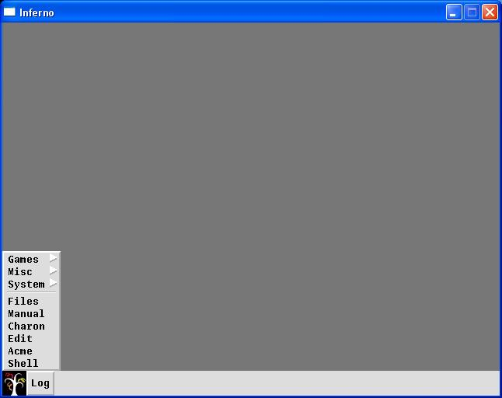
Click on the Vita Nuova logo in the bottom left to bring up the menu shown in this picture (the equivalent of Windows’ Start menu). Note that the window cannot be resized! If you want a bigger window, set the environment variable EMU to “-r<inferno root> -g1024x768” and restart Inferno. You can set the window to any size with the –g switch.
In the menu, click on Charon to launch the built-in web browser. This is rather basic, but functional. Play around with it. Close Charon and launch the Manual program from the “Start menu”. This displays the same information as the man command-line program but in a friendlier way.
The Inferno desktop is not designed as a replacement for Windows, KDE or any other heavyweight environment. Rather, it’s a lightweight container for simple GUI apps. These apps are written in Limbo, Inferno’s own programming language, which uses a variant of Tk for graphical interfaces. See “The Limbo programming language” below.
Launch a shell window from the “Start menu”. This gives you the same environment that you had from the command line. You can open as many shell windows as you like. Close each shell window by clicking the X in the top right-hand corner. This also kills any programs that have been started from this window. You can cut and paste within and between shell windows by using the middle mouse button (or scroll wheel). Note that “Snarf” essentially means “Copy”. If your mouse only has two buttons… get a three-button one (or one with a clickable scroll wheel)! It makes life an awful lot easier.
The Send command is particularly useful. Select a piece of text anywhere in the shell window (e.g. a previous command), click and hold the middle mouse button over it, highlight the word “Send” and release the middle button. The text will be copied and pasted at the command prompt and Enter is pressed for you. In other words, the text you selected will be entered as a command.

Key Inferno Concepts
Before we go any further, we should go through some key concepts of Inferno. It is these concepts that make Inferno such a good system for distributed computing.

Everything looks like a file
The most important concept in Inferno is that everything is virtualised as a file or set of files. We’ve already seen an example of this when we read the /dev/user file to get the name of the current user (see “Basic Inferno”). By contrast. other operating systems represent the current user name as an environment variable. Another example is that the current time can be found by reading the /dev/time file (with the command “cat /dev/time”). It is the logical extension of Unix’s metaphors of representing devices such as serial ports (/dev/ttyS0, etc) and the mouse (dev/mouse) as files. The important thing to realise is that this representation of everything as a file does not mean that everything is a file, in the sense of bytes on a hard disk.
Therefore, to interact with devices and programs in the Inferno world, we read from and write to files. This design replaces the more typical method of using APIs (Application Programming Interfaces) to interface with systems. The problem with the API approach is that it is essentially unbounded; there could be any number of API functions for a device. In contrast, the number of possible file operations are very small (see “The Styx protocol” below).

Namespaces
A hierarchy of files in an Inferno system is called a namespace. It is similar to a “filesystem” except that not all of the files in an Inferno namespace need be literal files on the hard disk. For example, the namespace for a digital camera might look like this:
/ (The root of the namespace)
|
-----------
| |
ctl images/

The ctl file is a special file (a synthetic file) that the user uses to send commands to the camera. For example, to take a picture, the user might enter the command “echo snap > ctl” (this writes the word “snap” to the ctl file). The resulting image can then be read from the images/ directory.

Mounting remote namespaces
To get access to namespaces exposed by remote system, we use the mount command. This is very similar in principle to Unix’s mount command; we specify what we want to mount and where in our own namespace we want to mount it. For example, if the namespace for the digital camera in the previous section was hosted on a computer called camera.somewhere.com on port 1234, we would enter the command “mount tcp!camera.somewhere.com!1234 /n/remote”. Then the namespace of the camera would appear in the /n/remote directory of our system. We could then take a picture by issuing the command “echo snap > /n/remote/ctl”. We shall try some more examples of the mount command later in this tutorial.

No difference between local and remote files
You may have noticed from the last paragraph that once we had mounted the remote camera’s namespace, we didn’t need to tell the echo command that /n/remote/ctl actually represented a remote file. This is because, in Inferno, applications do not know the difference between local and remote files. They use the same method for communicating with both. The applications simply send out messages and the operating system directs the messages to the correct destination. The protocol for these messages is called Styx.

The Styx protocol
All communications between Inferno systems, local and remote, are carried out using the Styx protocol (REF). Because all messages are file operations, the Styx protocol has a very small command set (only 13 commands). You can probably guess what many of the commands are: open, close, read, write, create and delete. You will not need to know anything about Styx – the only point to make here is that Styx is an open protocol, and implementations are available (or can be written fairly easily) for several languages, including Java. Therefore, an application does not have to run within Inferno to communicate with an Inferno system – it just has to be able to “speak” Styx.

The Limbo programming language
Applications in Inferno are written in Limbo, a C-like language that has native support for concurrent programming. Limbo programs are guaranteed to be portable across all installations of Inferno, with no exceptions. You’ll probably be glad to know that you won’t need to learn anything about Limbo to go through this tutorial. (see “Further reading” for more details). Remember that you can run native programs in the host operating system using the os command (see “Basic commands” above); this is what we’ll mainly be doing in this tutorial.

A simple distributed system
Now we’re ready to use these ideas to create a very simple distributed system. If you have two computers at your disposal and they are networked, you can install Inferno on both of them and work through the rest of this tutorial. If you only have access to one computer, you can still follow the tutorial by starting the Inferno desktop (see “GUI applications” above) and opening two shell windows. I shall call the two computers (imaginatively) computer1 and computer2 and colour their windows blue and red respectively in the diagrams below. If you are working on a single machine, please take “computer1” and “computer2” to mean “shell window 1” and “shell window 2”.

Listening for connections
On computer1, open a shell window and change to your home directory with the cd command. Create a new file called hello.txt with the contents “hello from computer 1” by running the command: “echo hello from computer 1 > hello.txt”. Verify that the file has been created by running lc, then view the contents of the file with “cat hello.txt”.
Now we can expose the whole of the home directory with a single command: “listen -A tcp!*!1234 { export /usr/Jon & }”. The listen command runs a server process to listen for network connections (run man listen for more details). The -A switch means “do not require authentication”. The argument tcp!*!1234 is Inferno’s version of a URL; it means “listen for TCP connections on port 1234”. The * means “this server” (analogous to “localhost”). When a connection is made, the command in the braces is run. This exports the directory /usr/Jon on the connection.
The screenshot below shows all these commands being executed in the shell window:
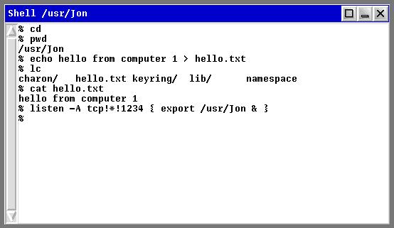

Making a connection
On computer2 (or a new shell window), we will now make a connection to this server. This is done in a single line: “mount –A tcp!computer1!1234 /n/remote”. (If you’re running this as two shell windows on the same machine, replace “computer1” with “localhost” or “127.0.0.1”.) Again, the –A switch means “do not use authentication”. You can view the contents of /n/remote with the command “lc /n/remote”. You should see the contents of /usr/Jon on computer1, complete with the file hello.txt that we just created. You can read the contents of hello.txt with the command “cat /n/remote/hello.txt”. You should get the response “hello from computer 1”.
The picture below shows all these commands (with the window bar coloured red to represent that this is computer2):
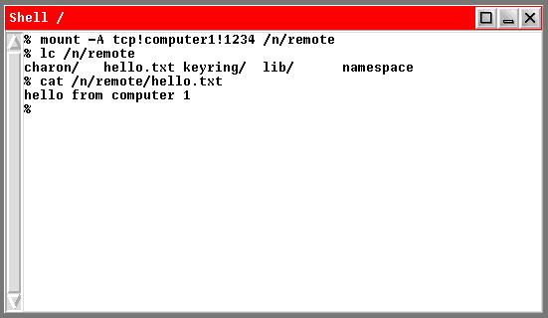
That’s how easy it is to create a simple distributed system in Inferno – just use the listen and mount commands. We have just shared some files (literal files on the hard disk), but because everything in Inferno is a file, exactly the same method is used for sharing any namespace.

Per-process namespaces
On computer2, open another shell window and examine the contents of the /n/remote directory with “lc /n/remote”. There’s nothing there! Why? This is another important concept in Inferno. Every process (and hence every shell window) maintains its own namespace. So if we modify the namespace in one shell window, all other shell windows (and all other processes) are unaffected. This is very handy. An application can mount resources in /n/remote without first having to check that this mount point is in use.
An exception to this is if a file on hard disk is changed within a namespace. In this case, all processes will see the change.

An Inferno Grid Service
Now we can start to build up a service-oriented distributed system. The file gridservicesrv.b (included with this distribution) is a Limbo program that implements a namespace that represents an entity that we shall call an Inferno Grid Service (it is similar in some ways to an OGSI-style Grid Service). Create a new directory in your Inferno home directory called GridService and copy gridservicesrv.b into this directory.
We’ll need to compile this Limbo program into an executable for the Dis virtual machine. Start Inferno on computer1, open a shell window and change to the GridService directory in your home directory (“cd /usr/Jon/GridService”). Compile the program with the command “limbo –gw gridservicesrv.b”. You should not get any errors or warnings (let me know if you do!). The executable (called gridservicesrv.dis) should have been created.
The Inferno Grid Service provides the wrapping for an executable that does the actual work. This executable is, in turn, wrapped in a simple Inferno shell script that “glues” the executable to the correct instance of the Inferno Grid Service. There is an example shell script included with this distribution, called testexec.sh. Take a moment to examine the contents. It is a very simple file; it simply mounts the correct Inferno Grid Service (IGS) instance, reads the time and outputs it to a stream. We’ll see it in action in a moment.
Copy testexec.sh to the GridService directory and make sure it is executable (run “chmod a+x testexec.sh”). Now we can run the IGS that will wrap the executable. From the GridService directory, run “gridservicesrv test testexec.sh /n/remote localhost 9876”. This command says “create an Inferno Grid Service called test that wraps the executable testexec.sh. Mount the IGS at /n/remote and we’re going to serve it on host localhost and port 9876”. [Note that on some systems you may have to replace “localhost” with “127.0.0.1”.]
Verify that the IGS is running and mounted by examining the contents of /n/remote with the command lc /n/remote. You should see a single directory called test – this is the root of the IGS. Examine the contents of test – there should be a single file, called clone.
The picture below shows a shell window with all those last few commands:
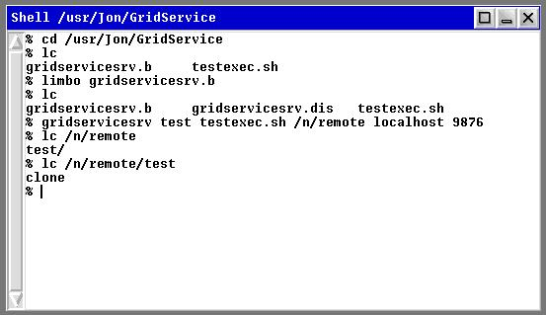

Creating a new Grid Service Instance
So far, we haven’t actually got any Inferno Grid Services, just the means to create them. Creating a new service instance could not be easier – simply read the clone file. The number that is read is the ID number of the IGS instance that has just been created. So, carrying on the above example, execute the command “cat /n/remote/test/clone”. This reads the clone file, which is a synthetic file on the server – i.e. it’s not a real file at all. When you read the file, the server gets the “read” message and uses it as a signal to create a new service instance. The server then replies with the ID of the new instance. So when you read the clone file for the first time, you’ll get the reply “0”. If you were to read the clone file a second time, you’d get the reply “1” and so forth.
Execute “lc /n/remote/test/” and you’ll see a new directory has been created for each service instance. Change into one of these directories with “cd /n/remote/test/0”. Examine the contents of the directory with lc. The last few commands in your shell window should look something like this:
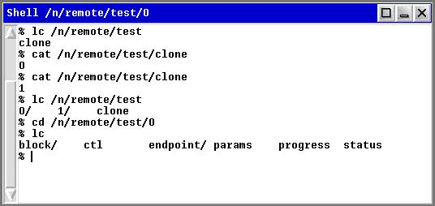
These files allow you to interact with the Inferno Grid Service instance and maintain the state of the service. Because each IGS instance is associated with a unique directory on the server, the state of each service is kept completely separate. Let’s examine each file in the IGS in turn:
- ctl: “ctl” is short for “control” and this file allows you to start the service running and to destroy the service when you’ve finished with it. (In future, this file will be used to pause, restart and stop a running service, but this is not yet implemented.)
- params: This file contains the parameters that will be passed to the executable that does the actual work of the service (in this case, testexec.sh).
- progress: This file contains the progress of the running service. The executable periodically writes progress information to this file, and other monitoring programs can read the file to get the progress information
- status: This contains a string representing the status of the service. When a service instance is first created, this file contains the string “not started” (try it – execute “cat status”). When the executable is set running this file will contain the string “started” and when the executable has finished it will contain the string “finished”.
- block/: This directory contains blocking files that are used to read progress or status in an asynchronous manner. We will discuss this more later (see section REF).
- endpoint/: This directory is the key behind the capability to stream data between services. It contains two files, in and out, which represent the ends of a pipe. The executable writes its data into the in file, and another process (i.e. the next service downstream in the pipeline) reads the data from the out file. We shall see this later (see “Running the service” below).
Note that this is only one possible arrangement of files to represent a service. More state data (in addition to progress and status) could be maintained and other features could be added by editing the gridservicesrv.b Limbo source file.

Exporting the service
Before the service can be run it needs to be exported so that applications can connect to it. Remember how we exported a namespace earlier using the listen command? (See “A simple distributed system” above.) What we’re about to do is very similar, except we’ll use the styxlisten command. styxlisten multiplexes a single server process between multiple clients; in contrast, the listen program starts a new server process for each client connection. To export our Inferno Grid Service on port 9876 (which is what we said we’d do when we ran the gridservicesrv program at the start of this section), run “styxlisten -A tcp!*!9876 { export /n/remote }”. Again the –A switch means “don’t use authentication”.
Check that you can connect to the IGS by mounting it: Open a separate shell window (or connect from a separate computer) and run “mount -A tcp!localhost!9876 /n/remote”. (Note that if you are connecting from a separate computer you will have to replace “localhost” with the hostname or IP address of the computer hosting the Grid Service.) Check that the files of the IGS have appeared in /n/remote with “lc /n/remote”.

Running the service
Running an IGS instance is very easy. You simply write the string “start” to the ctl file. Do this using the command “echo –n start > ctl” (the –n switch prevents the echo program from sending a newline after the “start” string). Nothing much will have happened on screen but here’s what’s going on behind the scenes (examine the testexec.sh file to see exactly what’s happening):
- The server recognises the attempt to write the string “start” into the ctl file and takes this as a signal to start the executable.
- The server starts the testexec.sh executable, passing the following arguments:
- The hostname of the IGS server
- The port of the IGS server
- The name of the IGS service (in this case “test”)
- The ID number of this particular IGS instance (e.g. “0”)
- The parameters to pass to the executable, i.e. the contents of the params file. There are no parameters in this case.
- The testexec.sh file then performs these tasks:
- It mounts the IGS server in its own namespace (remember that each process has its own namespace) with “mount -A tcp!$host!$port /n/remote” ($host and $port are the first two arguments passed to the testexec.sh file).
- It runs the program that does the actual work of the Inferno Grid Service. In this case this program is trivial: it just reads the present time. It redirects the standard output of this program to the input of the endpoint (HAVEN’T EXPLAINED THIS!) that is associated with this particular instance. The command to do all this is “cat /dev/time > /n/remote/$name/$sid/endpoint/in”, where $name and $sid are the name and ID of the the IGS instance.
- Finally, it writes an empty string into the input of the endpoint to signify that this is the end of the data using “echo –n > /n/remote/$name/$sid/endpoint/in”. (Writing an empty string to a file is Inferno’s way of signifying end-of-file.)
So, the output data from the service has been sent to the endpoint associated with this service instance. How do we get this data out? Easy – we just read from the output part of the endpoint. Let’s say we have the IGS mounted at /n/remote and we have just run instance 0 of the service. We can get the output data by running “cat /n/remote/test/0/endpoint/out”. The result is a long numeric string representing the time when the IGS was run. The screenshot below shows the last few steps in this tutorial:
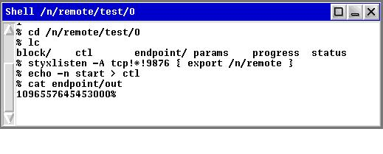

More about endpoints
The endpoint/ directory in an Inferno Grid Service is the key to data streaming. As I have mentioned, the two files in the endpoint/ directory (called “in” and “out”) are simply the two ends of a pipe. Whatever is written into the “in” file can be read from the “out” file. Try it – create an Inferno Grid Service instance as above and write some data into the endpoint/in file (e.g. “echo this inferno stuff is great > endpoint/in”). Now read the endpoint/out file with “cat /endpoint/out”. You should get whatever you put into the “in” file.
This is how data are streamed across a network. An Inferno Grid Service instance is created and started. The executable writes data into the endpoint/in file. A remote machine mounts the IGS into its own namespace and reads from endpoint/out. The remote machine doesn’t know that it’s reading data from a stream; it just thinks it’s downloading a file called endpoint/out.
A common problem often seen with data streaming is overflow and underflow. Overflow happens when the data generator (the upstream service) produces data faster than the consumer (the downstream service) can download it. Underflow is the converse, in which the consumer tries to download data faster than the generator can produce it. Both scenarios are handled transparently and reliably by Inferno. The pipe that sits behind the endpoint/in and endpoint/out files has a small buffer (32K I think – need to check this!). If the data production is faster than consumption, this buffer will fill up. Any attempts to write to endpoint/in will block until there is space in the buffer (in effect, the data producer will be paused). Similarly if data consumption is faster than production, the buffer will be empty, and subsequent attempts to read from endpoint/out will block until there is data in the buffer. Thus, a constant stream of data is maintained without data loss. This is handled by Inferno at the operating system level and applications don’t need to worry about it.

A “real” example
The example above was just a toy to illustrate how an Inferno Grid Service is created and used. Now we’ll create something that’s much more like a real, useful service. We’ll be able to monitor its progress from any remote machine. For this example, we’ll create an Inferno Grid Service that wraps a Java program that calculates the first n prime numbers, where n is specified by the user. Note that Inferno does not have a Java virtual machine; the Java program will run in the host operating system. This example could have been written in any language that the host OS can handle (real scientific applications in which performance is an issue will normally be C or FORTRAN programs).

First attempt
To start with, let’s create a service based around an unmodified executable. The downside of this first attempt is that we won’t be able to monitor the progress of the service; for this, we’ll need to modify the executable (which we’ll do in the next section). The executable that we’ll use is a Java program called CalcPrimes (included in the distribution in the “primes” directory). Test out the executable outside of Inferno by running “java CalcPrimes 100”. This will print out the first 100 prime numbers, separated by spaces. Examine the source code if you like – it’s a very basic algorithm!
Now start up Inferno. We’ll use the os command to run the Java program in the host operating system. Make sure this works by running “os java –cp /path/to/classes CalcPrimes 100”. For example, on Windows, you might run “os java –cp C:\docs\tutorial\primes CalcPrimes 100”. (This assumes that the java executable is in your PATH in the host OS.)
We’ve verified that Inferno can run the program. Now we’ll create an Inferno shell script to wrap the program. Make a copy of the testexec.sh file and call it calcprimes.sh (put it in the same directory, i.e. the GridService directory in your Inferno home directory). The only line we need to change is the one that executes the program itself, i.e. replace the line:
cat /dev/time > /n/remote/$name/$sid/endpoint/in
with the line:
os java -cp /path/to/classes CalcPrimes $params >
/n/remote/$name/$sid/endpoint/in
(set the classpath argument (-cp /path/to/classes) to the correct path to the CalcPrimes file in your host filesystem). An example script is in the “primes” directory of this distribution. Make sure the script is executable by running “chmod a+x calcprimes.sh” from within Inferno.
Open a new Inferno shell window and change to the GridService directory. (It’s probably best to close all other shell windows too so port clashes don’t occur.) Create an Inferno Grid Service called calcprimes with the command:
gridservicesrv calcprimes calcprimes.sh /n/remote localhost 9876
(if you get problems later on, you might need to use “127.0.0.1” instead of “localhost”). Verify that the IGS has been created by checking for the “calcprimes” directory in /n/remote. Export the service as before with:
styxlisten –A tcp!*!9876 { export /n/remote }
Create a new IGS instance by reading the clone file:
cat /n/remote/calcprimes/clone
You should get the response “0”; this is the ID of the new instance. Let’s use the service to calculate the first 10 primes. We must set the parameter to the CalcPrimes executable. We do this by writing the parameter into the params file of the IGS instance:
echo –n 10 > /n/remote/calcprimes/0/params
Now we can run the service:
echo –n start > /n/remote/calcprimes/0/ctl
(if you get an error at this point, check the calcprimes.sh file. You might need to run the gridservicesrv program again in a new window, replacing localhost with 127.0.0.1). As before, you can get the output from the program by reading the endpoint/out file:
cat /n/remote/calcprimes/0/endpoint/out
Your shell window should look pretty much like this:
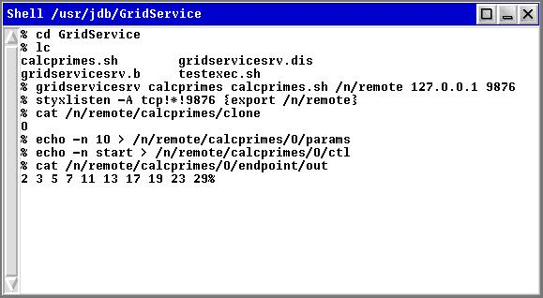
You can re-use the same instance if you like to calculate the first 100 primes. Just write the string “100” into the params file and run the service again as above.
STREAM DATA, MONITOR STATUS
Write a simple executable, wrap it in a script file and call it remotely. Read its output from endpoint/out. Monitor its status by reading block/status.

TODO: capture stderr (or redirect it to a file somewhere). Split streams. Deal with multiple streams.

A simple workflow
Chain a couple of IGSs together, preferably on different machines.

Wrapping as a Web Service

Java Styx libraries
Not complete yet, but only need to open a connection, read from and write to files. Wrap in java.io.InputStream and OutputStream.
Need to have “proper” understanding of styx:// URLs.
Major limitation is one message at a time per connection – so if reading blocking files, need several connections open.

Making a WS wrapper
All it does is this:
- Creates a new instance of the IGS
- Writes parameters into params file
- Starts the IGS off (“echo –n start > /n/ctl”)
- Returns with URL to IGS instance
Key point is that WSs in the workflow receive and output pointers (URLs) to IGS instances

Using Triana to call the workflow and monitor progress
Need the progress monitor widget and something to download the data. Emphasise that no firewall holes are needed on the client.

Appendix: How it works
Explanation of Limbo code, enough so that people can change at basic level if necessary. Pretty much like C except for: lists, pick adts, channels. Can compile Limbo code in Inferno or host OS.
Put up syntax highlighting for Kate?

Appendix: Command usage
gridservicesrv <service name> <executable to run> <mount point> <host>

Appendix: Security

Further reading

